Riversand Mass 230 gram
Sieve Size | Reading | Mass  Retained | Mass  Passing | Percent  Passing
 |  |  |  | 
 |  |  |  | 
 |  |  | 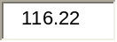 | 
 |  |  |  | 
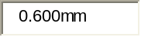 |  |  |  | 
 |  |  |  | 
 |  |  |  | 
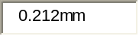 |  |  |  | 
 |  |  |  | 
 |  |  | 
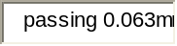

Crushed rock 237 gram

Sieve Size | Reading | Mass  Retained | Mass  Passing | Percent  Passing
 |  |  | 
 |  |  |  | 
 |  |  |  | 
 |  |  | 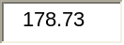 | 
 |  |  | 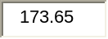 | 
 |  |  |  | 
 |  |  |  | 
 |  |  |  | 
 |  |  |  | 
 |  |  |  | 
 |  | 

